Selenium WebDriver – How To Run Multiple Test Suites Using Docker Compose – Part 2

Overview:
The modern cloud infrastructure, continuous integration & deployment processes etc have completely changed the way how applications are deployed in production nowadays. In order to release new features faster in Production, you need to reduce time we take in the each phase of the SDLC. As an automation lead/architect, It could be your responsibility to have a proper infrastructure to speed up the automated test execution! When it comes to infrastructure automation, Docker plays a major role there!
Testautomationguru already has few docker and selenium related articles which talks about setting up the dockerized selenium grid & running a docker container with a test.
- Setting up Dockerized Selenium grid.
- Running Automated Tests Inside A Docker Container – Part 1
Before continuing this article, I would request you to read the above 2 first! I am explaining few things here assuming that you have already read them.
This article is going to explain how to combine above 2 articles – ie running all regression testcases with multiple test suites & selenium grid with a single docker-compose file.

Test Suites:
We have thousands of automated tests for my application. I categorize / group them, based on the application business functionality / module and create multiple test suites. So that any change in specific module can trigger corresponding test suites.
Lets assume – in our sample application for this article, we have 3 modules.
- Registration Module
- Search Module
- Order Module
Lets also assume that, each module has hundreds of automated test cases already. In order to get my automated results as early as possible, We need to have multiple hosts + Selenium Grid set up as shown here to run the entire regression test suites!!

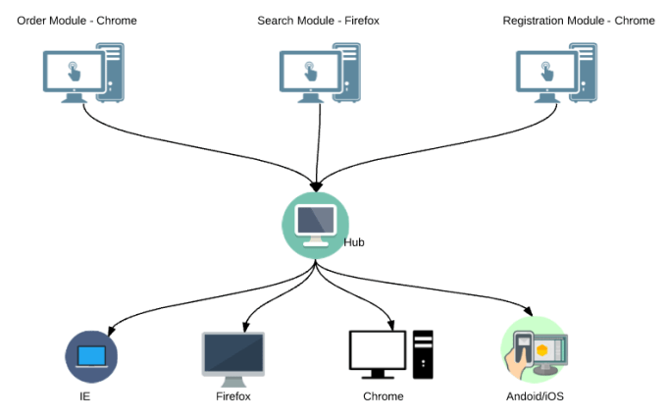

Setting up all the above machines with all the dependencies is a nightmare!
Lets see how we could set up the above entire infrastructure in a single compose file and execute the tests!!

Sample Project:
For the demo, I have created a simple project as shown here. This sample project is available in Github.
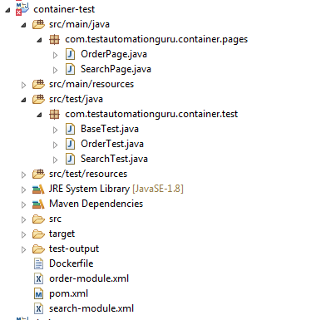
Page Objects:
- Above project has 2 page objects
  - SearchPage – acts as a page object for the search module (this is actually a page object for google search).
  - OrderPage – acts as a page object for order module (this is actually a page object for demoqa site).
Test Classes:
- BaseTest – a base test which contains the logic for driver instantiation.
- SearchTest – extends BaseTest – contains the test for the Search Module.
- OrderTest – extends BaseTest – contains the test for the Order Module.
Test Suites:
In real life, we will have multiple tests for a single module. In our sample project, we have only one test. We collect all the tests for a module and create a test suite file as shown here.
- order-module.xml – a testNG suite file which invokes order module tests.
<suite name="order-module" parallel="none" allow-return-values="true" >
<test name="order-test">
<classes>
<class name="com.testautomationguru.container.test.OrderTest"/>
</classes>
</test>
</suite>
Copy
- search-module.xml – a testNG suite file which invokes search module tests.
<suite name="search-module" parallel="none" allow-return-values="true" >
<test name="search-test">
<classes>
<class name="com.testautomationguru.container.test.SearchTest"/>
</classes>
</test>
</suite>
Copy
Test Requirement:
In order to do the complete regression testing for the application, Lets assume that we need to invoke the tests for both modules as given below.
- order module testing on chrome
- search module testing on firefox

Dockerfile:
I create the below Dockerfile which creates an image which contains all the dependencies to the run the test including the testNG suite files. [I have already explained this here – Please read the article if you have not already]
FROM openjdk:8-jre-slim

# Add the jar with all the dependencies
ADD target/container-test.jar /usr/share/tag/container-test.jar

# Add the suite xmls
ADD order-module.xml /usr/share/tag/order-module.xml
ADD search-module.xml /usr/share/tag/search-module.xml

# Command line to execute the test
# Expects below ennvironment variables
# BROWSER = chrome / firefox
# MODULE = order-module / search-module
# SELENIUM_HUB = selenium hub hostname / ipaddress

ENTRYPOINT /usr/bin/java -cp /usr/share/tag/container-test.jar -DseleniumHubHost=$SELENIUM_HUB -Dbrowser=$BROWSER org.testng.TestNG /usr/share/tag/$MODULE
Copy
So basically idea here is to create a single image which accepts browser, module as parameters – then create a container which tests specific module.

Creating An Image:
Executing below command compiles, packages the jar with all the dependencies and builds the docker image based on the above Dockerfile.
mvn clean package
Copy

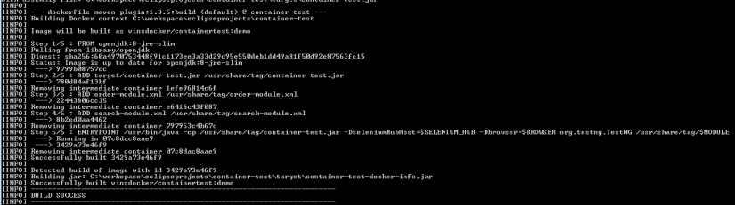

Docker Compose File:
Testautomationguru has already explained setting up the whole selenium grid infrastructure using docker-compose in this article – Setting up Dockerized Selenium grid.
version: "3"
services:
selenium-hub:
image: selenium/hub
container_name: selenium-hub
ports:
- "4444:4444"
chrome:
image: selenium/node-chrome
depends_on:
- selenium-hub
environment:
- HUB_PORT_4444_TCP_ADDR=selenium-hub
- HUB_PORT_4444_TCP_PORT=4444
firefox:
image: selenium/node-firefox
depends_on:
- selenium-hub
environment:
- HUB_PORT_4444_TCP_ADDR=selenium-hub
- HUB_PORT_4444_TCP_PORT=4444
Copy
We were able to successfully create a Selenium Grid using above docker compose file. Now we are going to add the image we created to create containers to test specific module.
search-module:
image: vinsdocker/containertest:demo
container_name: search-module
depends_on:
- chrome
- firefox
environment:
- MODULE=search-module.xml
- BROWSER=firefox
- SELENIUM_HUB=selenium-hub
volumes:
- /home/user/search-module-result:/output
order-module:
image: vinsdocker/containertest:demo
container_name: order-module
depends_on:
- chrome
- firefox
environment:
- MODULE=order-module.xml
- BROWSER=chrome
- SELENIUM_HUB=selenium-hub
volumes:
- /home/user/order-module-result:/output
Copy
- depends_on – lets the docker know that the service should be created once the all the dependent containers have been created.
- volumes – TestNG writes the result in the output directory inside the container. We map the directory to some directory on the host machine. Ensure that you provide enough permission to write results.
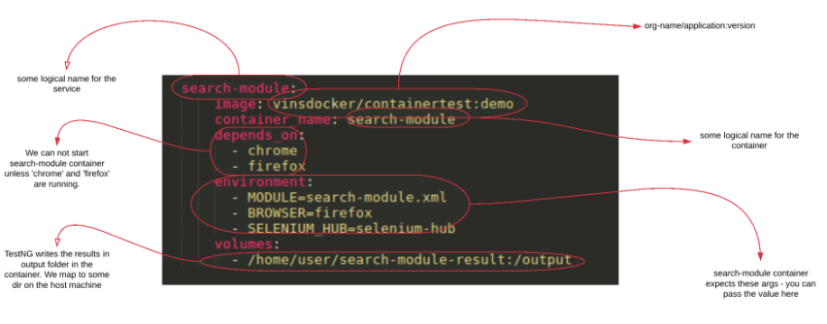

Test Suites Execution:
Once the docker compose file is ready, the rest is very simple!!
- A single command creates the entire infrastructure and executes the test.
sudo docker-compose up -d
Creating selenium-hub
Creating sel_firefox_1
Creating sel_chrome_1
Creating order-module
Creating search-module
Copy
- Execute the below command to see the status
sudo docker-compose ps
Name Command State Ports
-------------------------------------------------------------------------------
order-module /bin/sh -c /usr/bin/java - ... Up
search-module /bin/sh -c /usr/bin/java - ... Up
sel_chrome_1 /opt/bin/entry_point.sh Up
sel_firefox_1 /opt/bin/entry_point.sh Up
selenium-hub /opt/bin/entry_point.sh Up 0.0.0.0:4444->4444/tcp
Copy
- Once the test execution is done, you would see Exit 0 (in case of any test failures, you would see Exit 1)
sudo docker-compose ps
Name Command State Ports
-------------------------------------------------------------------------------
order-module /bin/sh -c /usr/bin/java - ... Exit 0
search-module /bin/sh -c /usr/bin/java - ... Exit 0
sel_chrome_1 /opt/bin/entry_point.sh Up
sel_firefox_1 /opt/bin/entry_point.sh Up
selenium-hub /opt/bin/entry_point.sh Up 0.0.0.0:4444->4444/tcp
Copy
- If you are curious to see the test log of order-module and search-module only, then go for below command.
sudo docker-compose up | grep -e 'order-module' -e 'search-module'
Copy
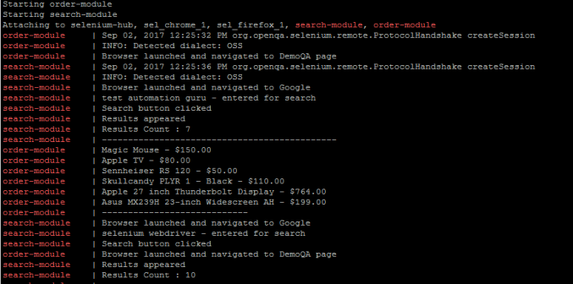
- To bring everything down, of course with a single command!
sudo docker-compose down
Removing search-module ... done
Removing order-module ... done
Removing sel_firefox_1 ... done
Removing sel_chrome_1 ... done
Removing selenium-hub ... done
Copy
Now the very complex selenium grid + hosts to run the java tests became very simple which you could define it in a text file. A single command creates the infrastructure in a second on a single host (you can also do that in multiple hosts) and disposes once everything is complete!

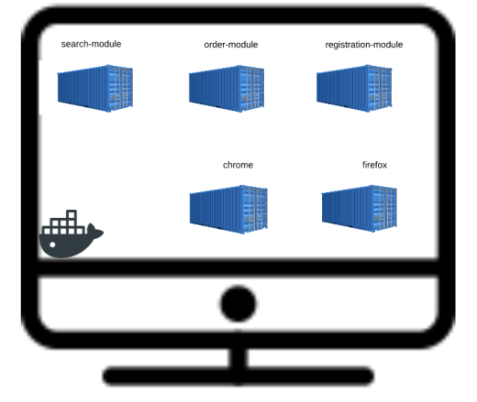

GitHub:
This sample project is available here.

Summary:
Docker compose made our life very easier! With a single command, we create Virtual Machines (containers are light weight VMs) with required browsers, tests and executes the test. Again with another command, we bring the entire infrastructure down!!
No more environment specific issues like ‘the test is not working in the machine’ ??
By implementing docker in your project, you become 100% awesome as Barney!!

What Next?:
We are able to build docker image for your automated tests with all the dependencies. How to distribute this image with other machines to run your tests? If you would like to know more about this, please check here.
Selenium WebDriver – How To Distribute Docker Images – Part 3

